Problem Title/Label XXXXXX
Product Owner xxxx
Problem Background/Context |  |  |  |  |  | Theme
INSTRUCTIONS: <<Include a problem Background describing the past (historical) facts leading up to an event or that describe a users’ problem>>  <<Mention out the Context for describing the circumstances in which a user uses a product>>  Example: “Two years ago, I started a dog grooming business, Angie’s Doggie Spa. Due to my business size, I have used a basic paper system to help me keep track of my customers, their dogs, and the services they purchased. This has worked up to this point, but with my growth, this is no longer feasible.” |  |  |  |  |  | ☒ |  | Digitization
 |  |  |  |  |  | ☐ |  | Advanced Analytics
 |  |  |  |  |  | ☐ |  | Automation @ Scale
 |  |  |  |  |  | ☐ |  | Client Centricity
 |  |  |  |  |  | Alignment to Skillset
 |  |  |  |  |  | ☒ |  | Lean Business Analytics
 |  |  |  |  |  | ☐ |  | Intelligent Business
 |  |  |  |  |  | ☐ |  | Automation
 |  |  |  |  |  | ☐ |  | Data Science
 |  |  |  |  |  | ☐ |  | Performance
Current Process
INSTRUCTIONS: <<Describe the current process end-to-end>>

Example:
- Customer schedules grooming (via telephone, email, or -in person)
  - Locate customer file, create new one if unable to locate or if new customer
  - Capture date, time, pet name, services, groomer, and any special instructions
- Customer drops off dog for grooming
  - Customer signs service waiver (if not on file – one per customer)
  - Validate services to be rendered
  - Add any additional special instructions to service appointment
  - Inform customer of the total cost and time their pet will be ready
  - ALTERNATE PATH - If the customer does not show up for their appointment, we call them to reschedule
- Grooming
  - Using service appointment as a guide, perform services
    - Grooming services include nail trim, fur clip, bathe, and brush – additional services could be added in the future
    - Grooming services are only for dogs - not expected to change to include any other animals
  - Update customer records to document the completed services
  - Inform customer via preferred contact method that their pet is ready
- Customer picks up dog from grooming
  - Locate customer file
  - Provide groomed dog and answer any questions
  - Provide total and take payment – credit card only

Challenges I am facing
INSTRUCTIONS: <<List out all the challenges that are caused by the problem>>

Example:
- Papers are easily lost or thrown away, losing valuable data about customers and their dogs
- Must manually find the customer documents and then page through them to remember what services they used in the past
- The more customers I get, the more file cabinets I need to maintain – not much office space remaining
- If I were to open a second location (part of my 5 year plan), the customer and service data could be spread between two different locations
- Reporting of earnings is manual making it prone to calculation mistakes and tedious to put together each week, month, and year - No easy way to compile the data of services per month (number of services, revenue from services, filtered by month)
Identified Users/Users Groups
<<Add User/User Group 1>>  (e.g. Customer) |  |  | INSTRUCTIONS <<User’s Hopes, wants and dreams>>  e.g. Want the overall experience to be as close to the same as feasible
<<Add User/User Group 2>>  (e.g. Employee) |  |  | INSTRUCTIONS <<User’s Hopes, wants and dreams>>  e.g. Keep the same relative process steps (although more efficient)
<<Add User/User Group 3>>  (e.g. Manager) |  |  | INSTRUCTIONS <<User’s Hopes, wants and dreams>>  e.g. Can see and interact with past customer data in the new system
Assumptions
INSTRUCTIONS <<If you are make assumptions for the missing details, be sure to list those assumptions here>>

User Activities (High-level)
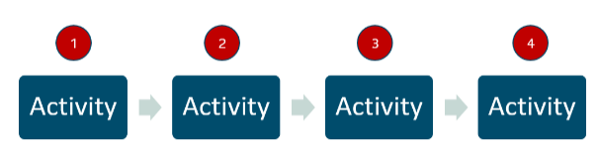
INSTRUCTIONS: <<Start by mapping out how users would do things in the real world - in chronological order.>>

Example
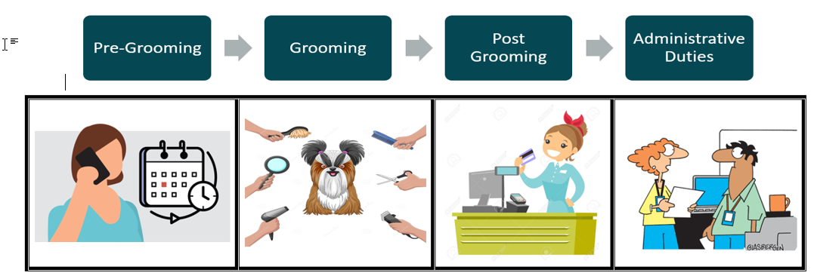

Adding Tasks for each Activity
INSTRUCTIONS: <<Now, break down each of the activities into a set of tasks. >>

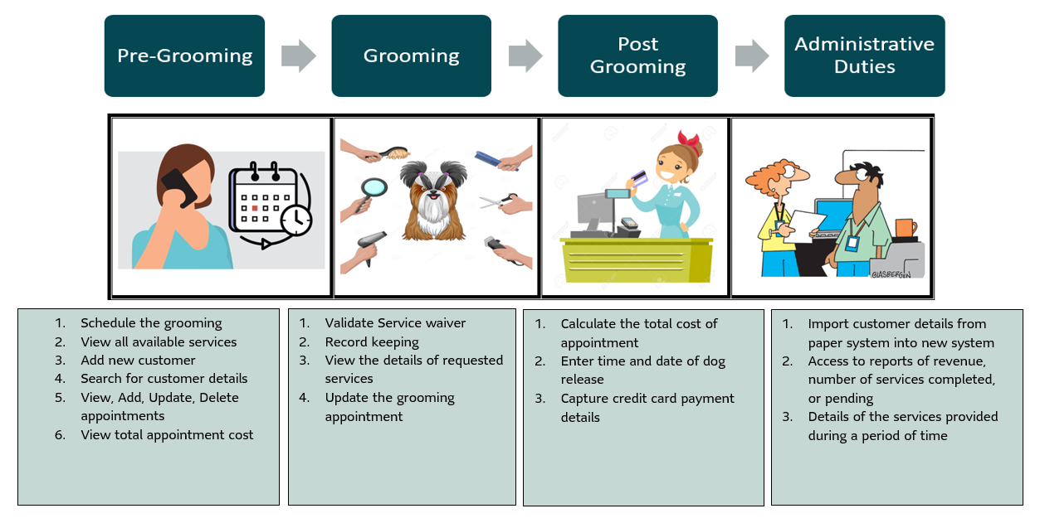

User Stories (Product Backlog)
User Story No.___ | As a user (who) Click or tap here to enter text. I want (the what) Click or tap here to enter text. So that (why) Click or tap here to enter text.
Acceptance Criteria

- Given I am Click or tap here to enter text. When I Click or tap here to enter text. Then, I should Click or tap here to enter text.
- Given I am Click or tap here to enter text. When I Click or tap here to enter text. Then, I should Click or tap here to enter text.
- Given I am Click or tap here to enter text. When I Click or tap here to enter text. Then, I should Click or tap here to enter text.

Examples
e.g. User Story No.1.1 | As a (who) Customer I want (the what) to schedule a grooming So that (why) I can have my dog groomed at a time convenient for me
Acceptance Criteria

- Given I am Customer When I find it convenient Then, I should be able to schedule a grooming session for my dog
- Given I am Customer When I call Angie’s doggy spa Then, I should be able to book appointment
- Given I am customer When I check online Then, I should be able to book appointment for my dog

e.g. User Story No.2.1 | As a (who) employee I want (the what) to see details of the scheduled appointment So that (why) I can perform the requested grooming services
Acceptance Criteria

- Given I am employee When I am performing the services Then, I should be able to view requested services details
- Given I am employee When I check services assigned to me Then, I should view customer appointment details

e.g. User Story No.3.1 | As a (who) Manager I want (the what) I want access to a report of revenue with the information about the number of services completed between a date range So that (why) I can compare with previous data to track how the business is doing and make the business decisions.
Acceptance Criteria

- Given I am Manager When I check records Then, I should be able to access completed services details
- Given I am Manager When I run report Then, I should be able to access total revenue generated for a given duration
- Given I am Manager When I run report Then, I should be able to download the report for comparison

User Story Map
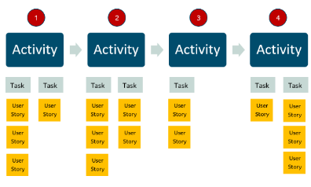
INSTRUCTIONS: <<Map the user stories (from backlog) to their corresponding task>>

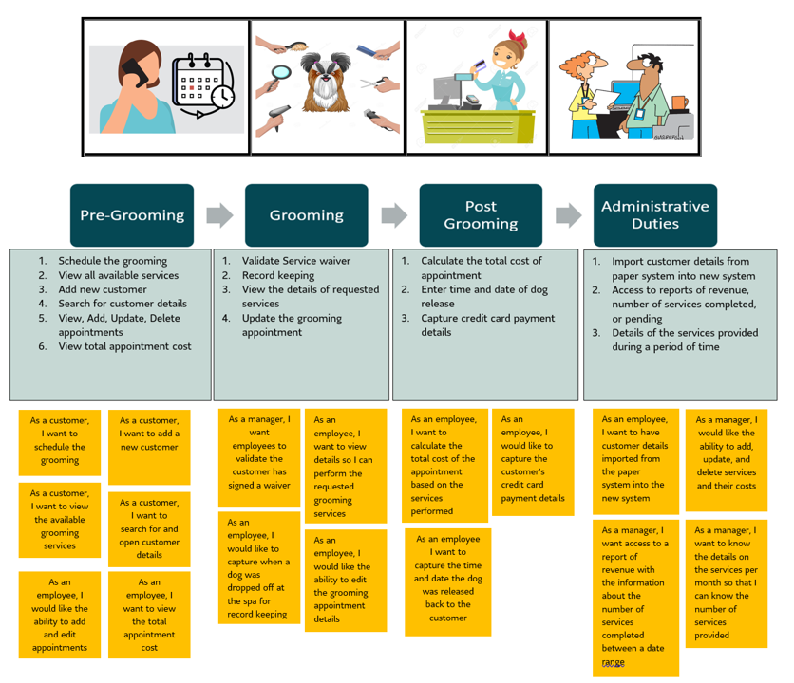

Key Near term Priorities (Sprint no.)
INSTRUCTIONS: <<Prioritize tasks and estimate relative releases referencing the User Story Map>>
Example:
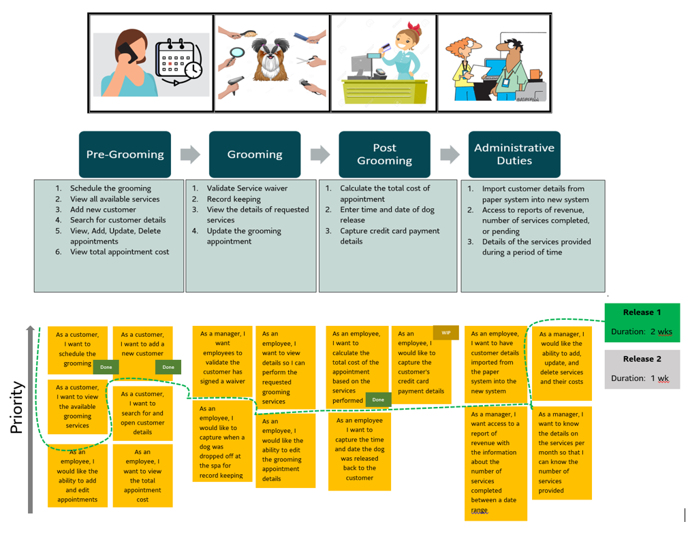
What are the Expected Outcomes?
- Click or tap here to enter text.. |  |  |  |  | (Associated OKR) |  |  |  | (Associated KPI)
- Click or tap here to enter text.. |  |  |  |  | (Associated OKR) |  |  |  | (Associated KPI)
- Click or tap here to enter text.. |  |  |  |  | (Associated OKR) |  |  |  | (Associated KPI)
Examples
- Converting paper system tracking to digital tracking of customer. |  |  |  |  | __% Targeted Digitalization |  |  |  | Innovation
- Customer data travel easily between different locations. |  |  |  |  | __% Reduction in Waste |  |  |  | Operations
- Automated Reporting of earnings minimizes calculation mistake |  |  |  |  | __% Error Reduction |  |  |  | Revenue
Is it a sizeable opportunity? (Decision)
Estimated FTEs required
Failure demand
- Client errors and escalations |  |  |  | (Current) |  | (Expected)
- Write Offs |  |  |  | (Current) |  | (Expected)
- TAT |  |  |  | (Current) |  | (Expected)
Cost of quality
Client Experience /Client Satisfaction Score |  |  |  | (Current) |  | (Expected)
Impact & risk score
(Additional Metrics)
Overall Sponsor Rating/Decision

